Kent Roller

A Lab on Capture-Recapture

This lab is supposed to simulate a real capture-recapture situation, where we tag animals in a forest, release and then after a while (time enough for the tagged animals to really mix with the other animals), come back and check from the animals we encounter how many are tagged.
I TAGGING PROCESS
I’ve completed the following steps for you:
a) Draw 50 elements, so n₁ = 50 (this is an arbitrary sample size)
b) Tag them using a marker/pen/pencil with the letter A.
c) Return the sample to the population, mix it very well

II Plan A DIRECT SAMPLING
I’ve completed number 1) for you as well:
1) Select a random sample of 25 (another arbitrary number) from the population.
Report how many of them were marked m = ____6_____
2) Estimate the population size using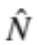(show your work):
Note, is called Peterson’s estimator.
n1=50
n2=25
m=6

50*25/6=208.333
3) Compute a 95% confidence interval (show your work):

(50ˆ2*25*(25-6))/6ˆ3=5497.685
=
208.33+1.96*sqrt(5497.685)=353.6569
208.33-1.96*sqrt(5497.685)=63.0031
(63.0031,353.6569)

4) What is the width of the confidence interval? ~290___________

5 )Estimate the population size now using Chapman's estimator, 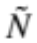(show your work):
N˜ = ((n1 + 1) ∗ (n2 + 1)/m + 1) – 1
((50+1)*(25+1)/(6+1))-1
=188.4286

6) Compute a 95% confidence interval (show your work):

V(N˜) = ((n1 + 1) ∗ (n2 + 1) ∗ (n1 − m) ∗ (n2 − m))/((m + 1)2 ∗ (m + 2))
((50+1)*(25+1)*(50-6)*(25-6))/((6+1)ˆ2*(6+2))
=2827.898

N˜ + / − 1.96(p V ∗ N˜)

188.4286+1.96*sqrt(2827.898)
188.4286-1.96*sqrt(2827.898)

(84.19975,292.6574)

7) What is the width of the confidence interval?
~208

FOR THE NEXT PLAN, I RETURNED THE SAMPLE TO THE POPULATION AND MIXED THEM VERY WELL.

III Plan B INDIRECT SAMPLING
I’ve complete the following for you:
Now, select at random one by one elements from the population until you get 10 that are marked. How many did you need to select in order to accomplish that? ____31_______
- Estimate the population size using inverse sampling

- Find the point estimate using the formula below: 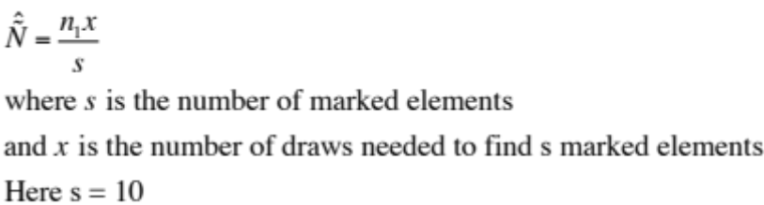
s is marked =10, 31 draws needs, n1 still 50?
(50*31)/10=155
- Compute a 95% confidence interval (show your work) using the formula below:
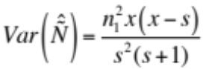
((50ˆ2*31)*(31-10))/(10ˆ2*(10+1))=1479.545

155+1.96*sqrt(1479.545)
155-1.96*sqrt(1479.545)
=(79.60889,230.3911)
- What is the width of the confidence interval? _____~151_____________

IV EVALUATING YOUR RESULTS
I counted the elements in the population and there were 246 elements.
- Now count the elements in the population __246______

- Calculate the difference (error) between the point estimate and the true population for each case (negative sign is underestimation, positive sign is overestimation)
- Peterson’s formula ___-38_________
- Chapman’s formula _____-58________
- Inverse sampling ____-91__________

3. Check if the true population size is in the 95% confidence interval you estimated.
With Peterson 's formula Yes

With Chapman's formula Yes

With inverse sampling No

- Write a paragraph summarizing the results.
With Petersons formula we had both the closest total estimate out of the three methods. The confidence interval was the by far the widest of the three methods. With chapmans formula our total estimation was further away from the true value, but the confidence interval was tighter than that of the Petersons formula, and still contained the true value. The inverse sampling method resulted in a total estimation that was the furthest away from the true value. The inverse sampling method did have the smallest Confidence Interval, however, the confidence interval did not contain the true value for the population as total. As such, based of this obtained information, the suggested method would depend on desired outcome. For a more accurate population total estimate, the Peterson Formula should be used. For a more precise confidence interval estimation the Chapman formula should be used. The inverse sampling method should not be used, n may be too small for this method, but it lacks both accuracy and precision compared to the other methods.

